FRESH BOWL

Prajwal

# Restaurant Concept

**Restaurant Name & URL**

Fresh Bowl

Freshbowl.in

**Food & drink**

Custom food bowls

* South-Indian – idly, vada, dosa, upma.
* North-Indian – Indian bread, curry, desserts.
* Oriental – szechuan, anhui, fujain.
* Continental – pie, steak, burger, pasta.

Drinks

* Fresh fruit/vegetable juice
* Tea, coffee
* Lassi
* Soups
* Smoothies, milkshakes

**Location**

India, Bangalore, Bangalore urban

Delivery radius: Bangalore urban

**Main target audience**

Busy working folks who would want to eat fresh food.

**Cost**

$ - Moderate.

**Elevator pitch**

We provide fresh, high quality, Moderately priced food to Bangalore. We provide the food you crave. Busy or tired to cook, just order to eat healthy and tasty food.

# Strategy

## Target Audience

The website/app will focus on the following target audiences:

**Roles** (groups of people with similar goals)

* Working people.
* People open to new food
* Busy to cook food.

**Demographics**

* **Gender** – both but more inclined towards women
* **Education** – college education or higher
* **Occupations** – working in various fields
* **Age** – 20 and above
* **Location** -Urban

**Psychographics** (personality, values, attitudes, interests, lifestyles)

* **Personality & Attitudes:** 
  + - Professional
    - fit
* **Values:** 
  + - Open – minded
    - Eat healthy food
* **Lifestyles:**
  + - Busy
    - Family
    - Tired

# 

# Strategy

## User Needs

The website needs to enable the user to:

* Find out if the restaurant delivers to their area
* Order food online
* Follow order after it has been placed
* Customize their food bowl
* Expect fast, quality service

## Client Needs

The website needs to enable the client to:

* To sell food online that will be delivered
* Provide a system for order customization
* Communicate freshness
* Communicate affordability
* Communicate reliability

# Outline of Scope

## Content Requirements

Content (text, images, video) that the user will need.   
*“The user will be looking for…”*

* Food menu
* Delivery radius
* Display prices
* Images of food
* testimonials
* Delivery speed
* Contact
* FAQ
  + Delivery cost
  + Is the food fresh?
  + Time to deliver
  + Minimum order amount
  + Delivery radius

## 

## Functionality Requirements

Systems that will allow the user accomplish tasks.

*“The user will be able to…”*

* Choose from pre – made food bowl
* Create a custom food bowl
* Place order
  + Make payment

Delivery address

* Track your order
* Create account
  + View past/current order
  + Reviews on previous orders

# Sitemap

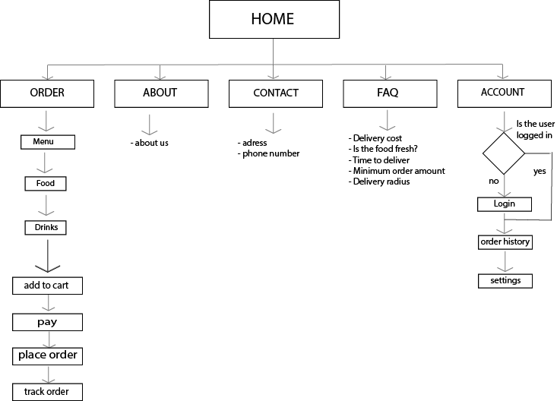

WIREFRAMES  
Mobile layout

HOME PAGE 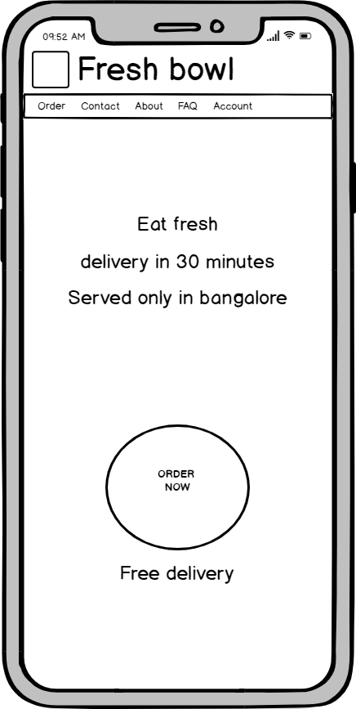

Ordering process – select under drinks/food 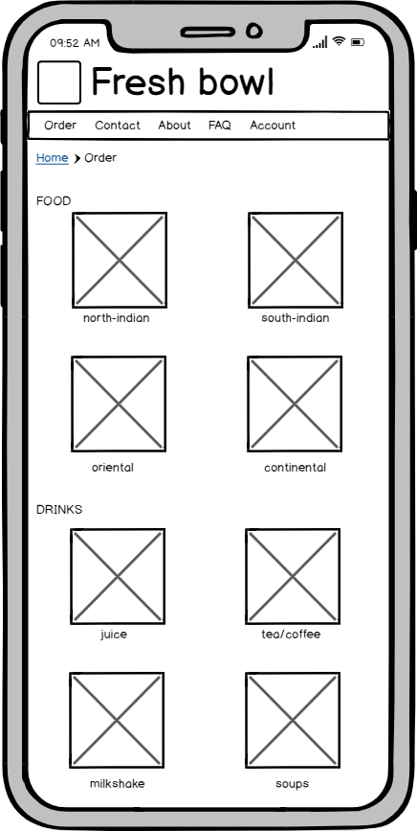

Ordering process – select the food 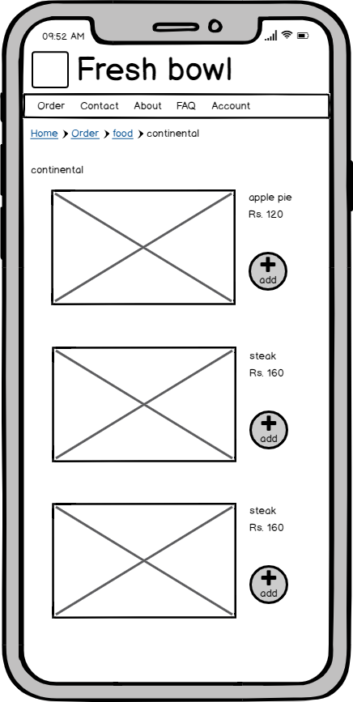

Ordering process – view shopping cart 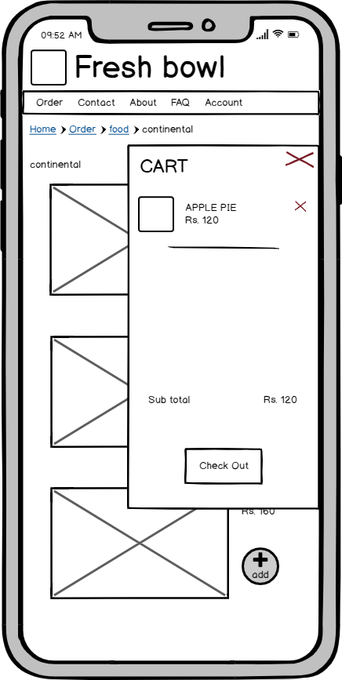

Ordering process – select the drink 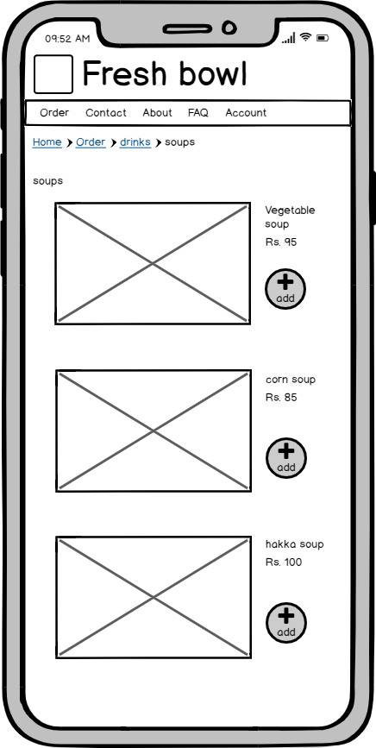

Ordering process – view shopping cart and check out 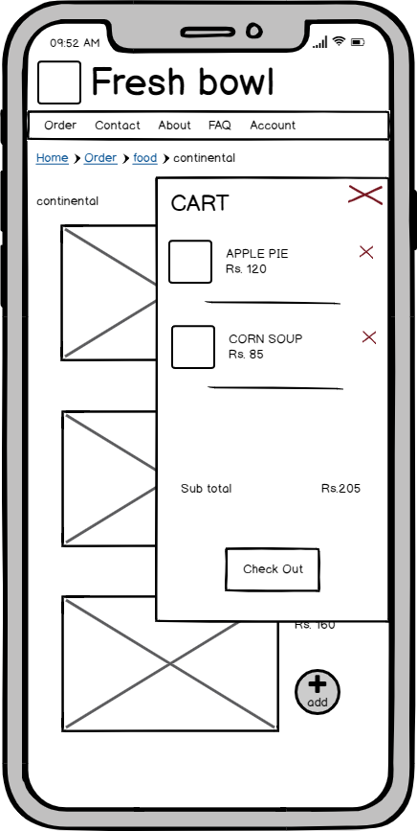

Ordering process – pay and place order 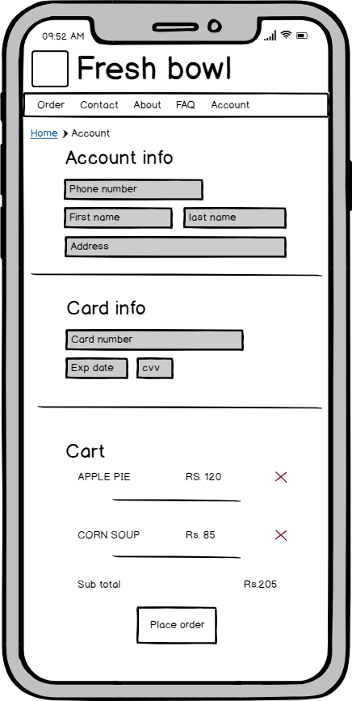

Ordering process – track your order 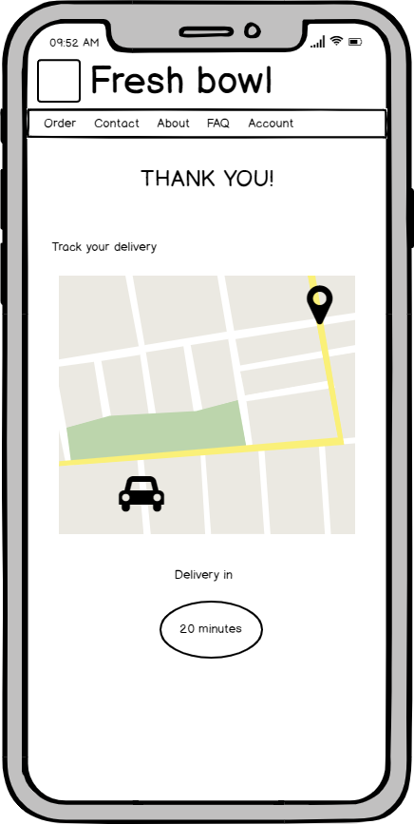

Additional page – account page wireframe 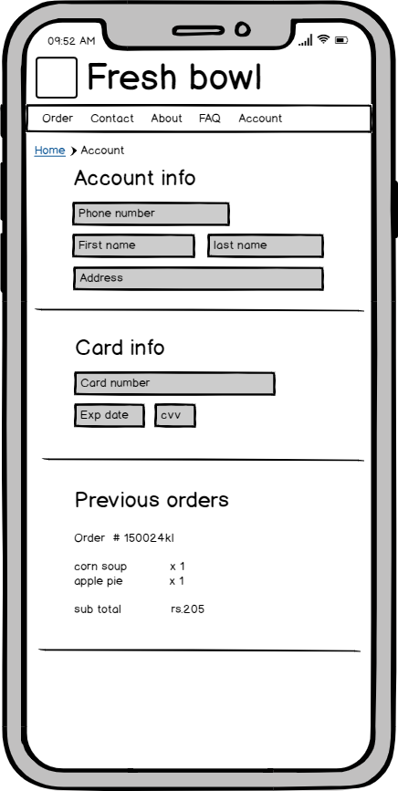

Desktop home page wireframe

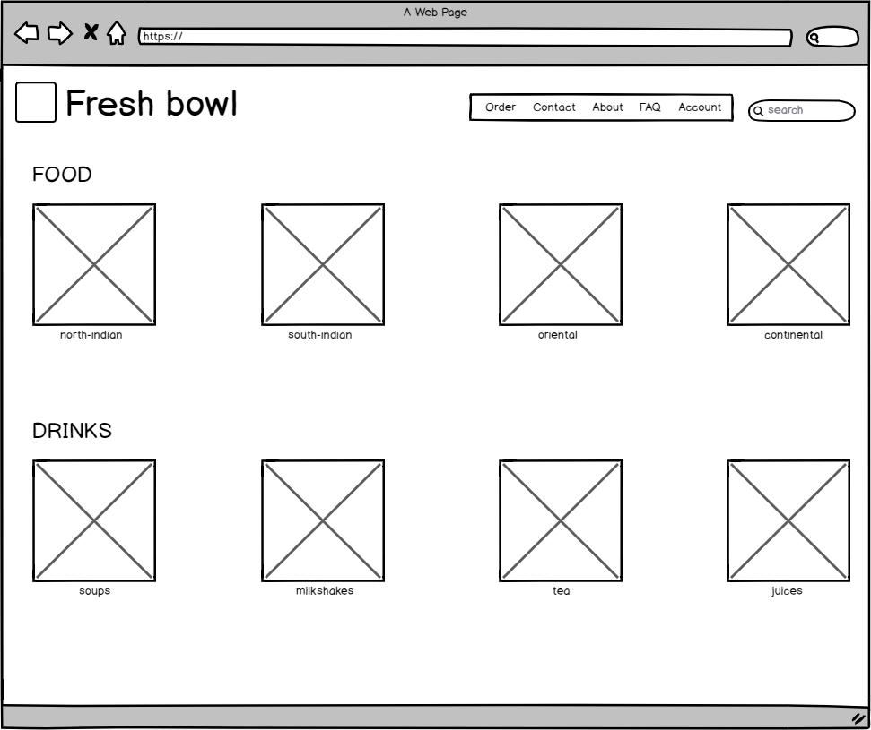

VISUAL MOCKUPS

Mood board

Logo development

Homepage

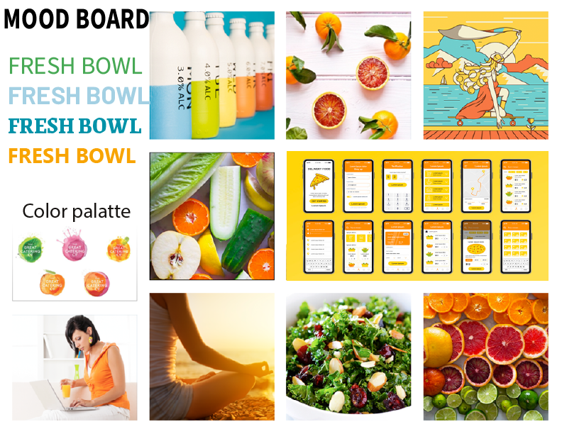

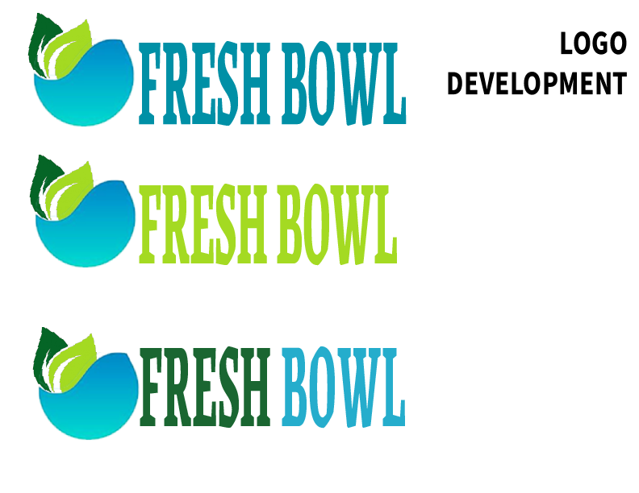

DESKTOP HOME PAGE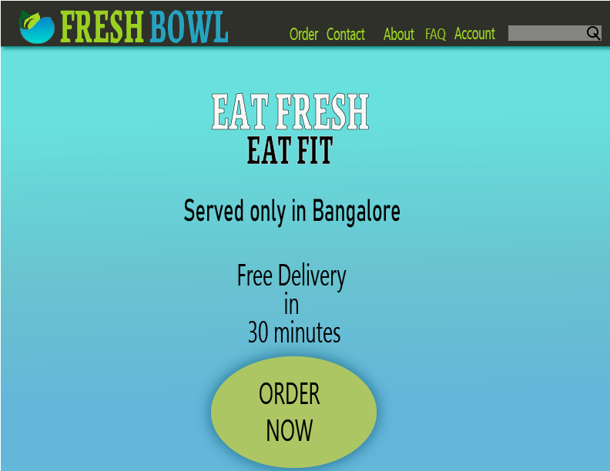

DESKTOP PAGE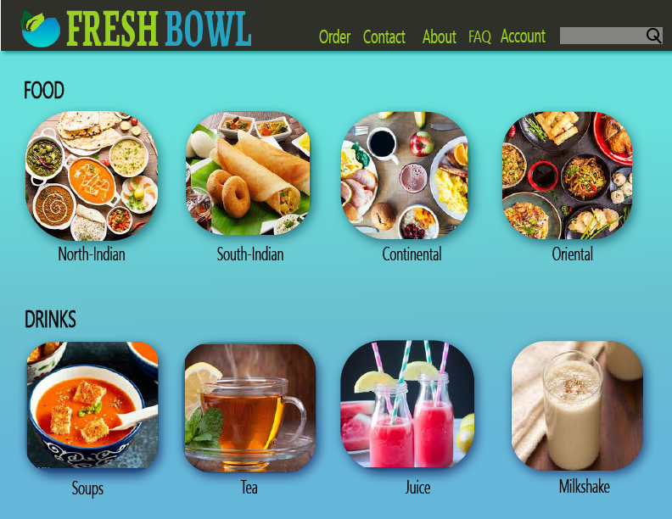

VISUAL MOCKUPS

FULL SET OF MOBILE WEBSITE

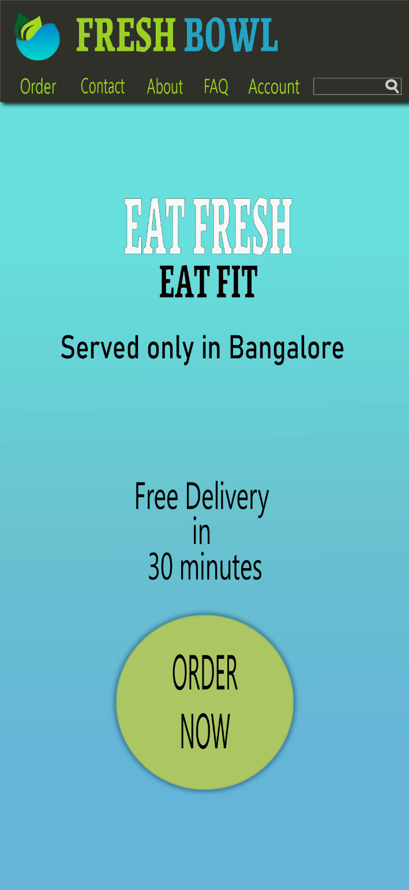MOBILE HOME PAGE

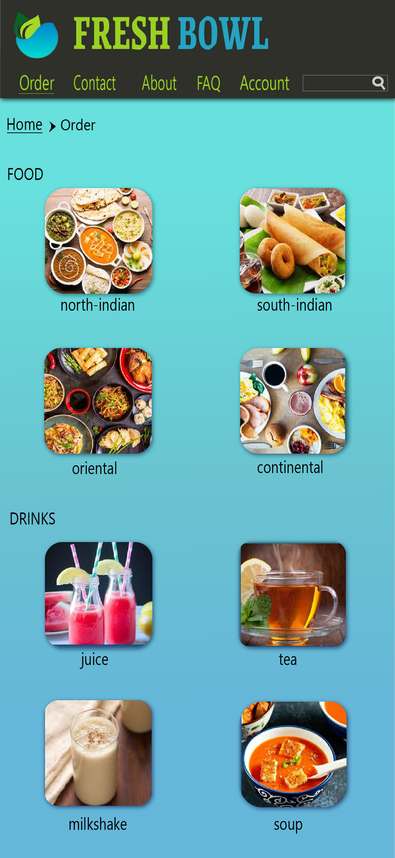MOBILE ORDERING PROCESS

–select under food or drink

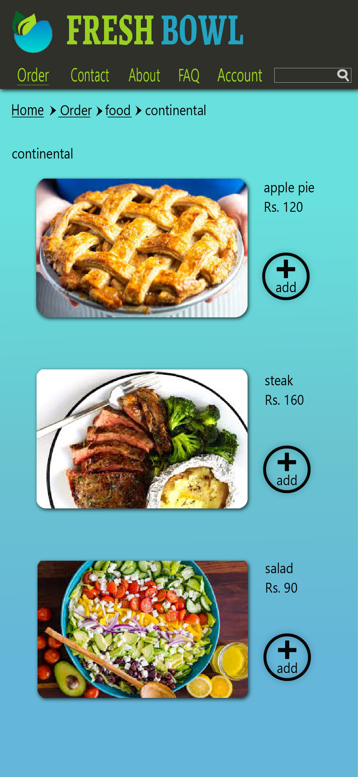MOBILE ORDERING PROCESS

– select food

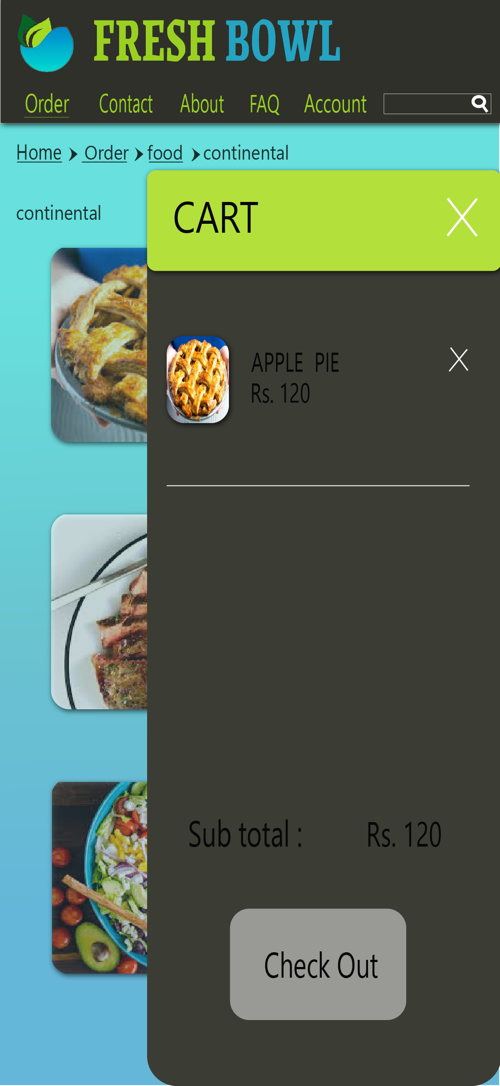MOBILE ORDERING PROCESS

– cart showing selected food

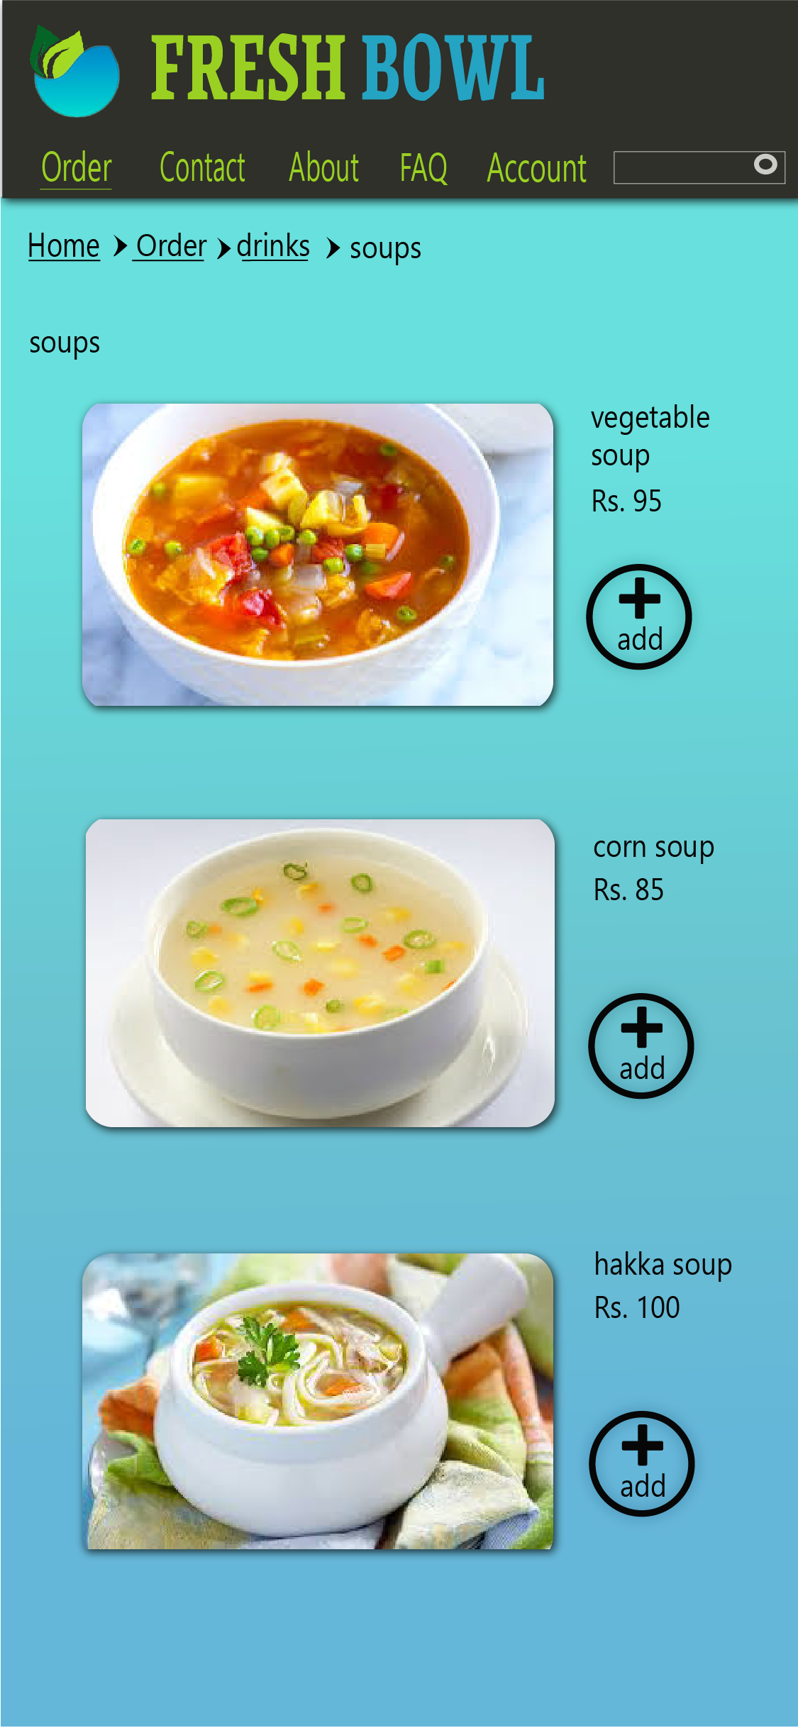

MOBILE ORDERING PROCESS

– select drink

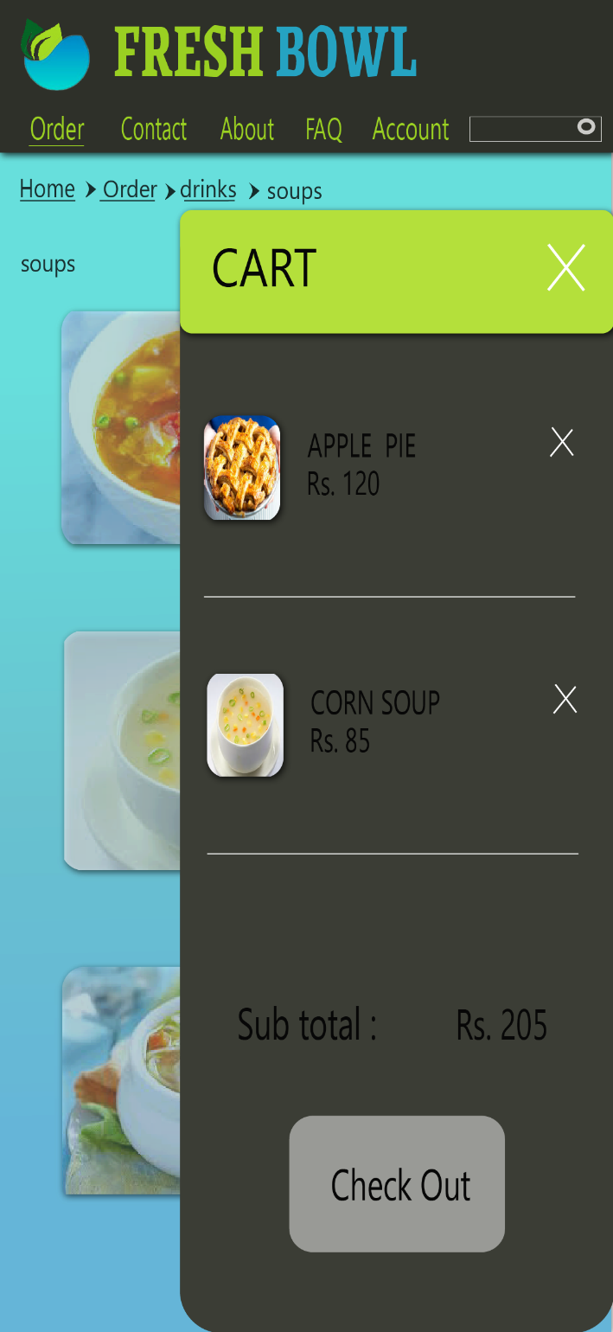

MOBILE ORDERING PROCESS

– cart displaying selected food and drink

And check out

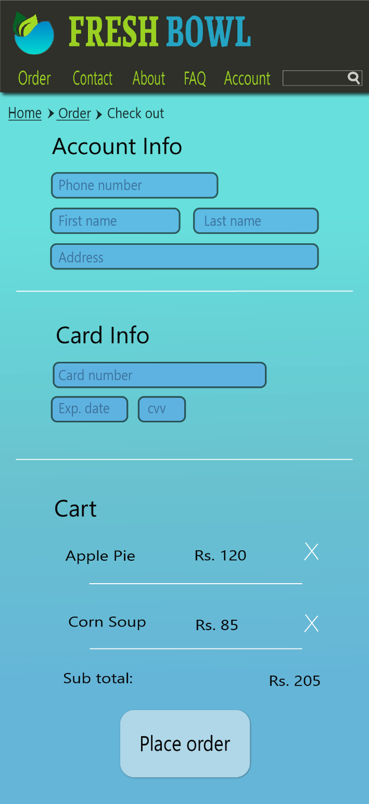MOBILE ORDERING PROCESS

– enter details for payment and place order

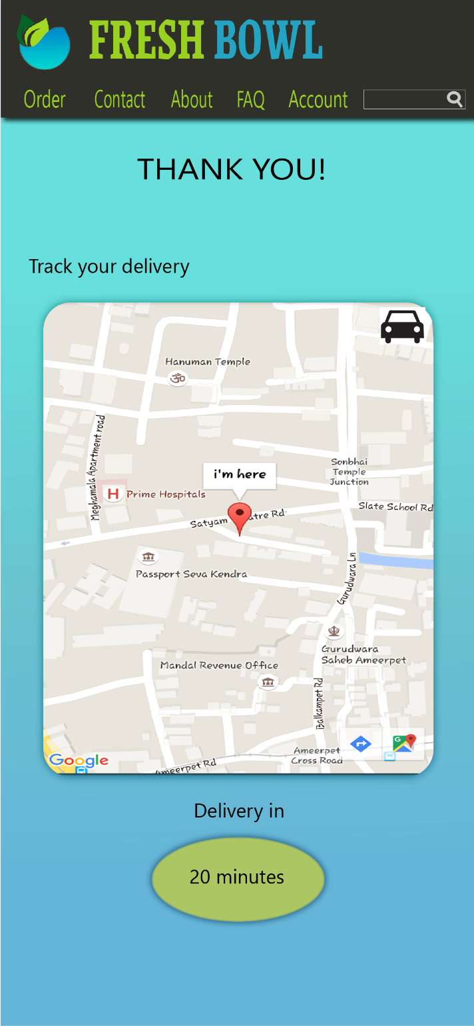MOBILE ORDERING PROCESS

– track your order

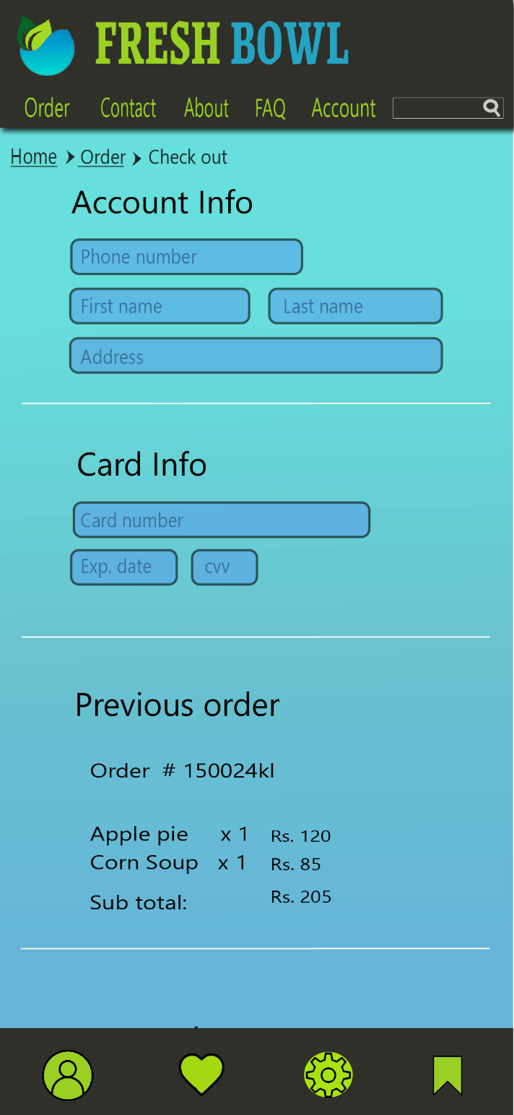MOBILE ACCOUNT PAGE

– Additional page